❶ **Put the following vocabulary into the correct category:**

**ORANGE CHICKEN APRICOT LEEK TOFFEE BROCCOLI VEAL**

**CARROT CHOCOLATE KIWI MARSHMALLOW MELON**

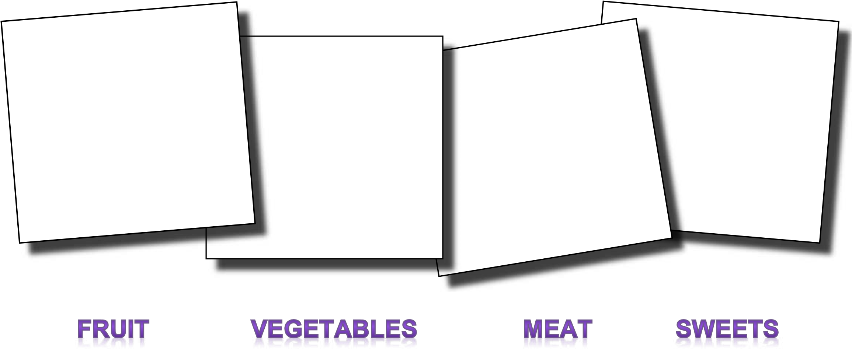

❷❷ **Try to add five more words to each list and one more category of food!**

❸❸ **Match the adjectives below with the food above.**



Example: **Chocolate**

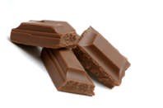

Milk chocolate is sweet and dark chocolate can be a little bitter.

❹❹ Now describe your favorite food or dish to your partner. Can your partner guess what it is?

What is your favorite food For Breakfast, describe it taste and texture ????

E.g Example – My favorite food for breakfast is

What is your favorite Food For Lunch describe it taste and texture???

What is your favorite food For Dinner describe it taste and texture ???

At The Restaurant Types of Menus ???????